Project Development Phase
Model Performance Test

Date | 10 February 2025
Team ID | PNT2022TMIDxxxxxx
Project Name | Project - xxx
Maximum Marks | 10 Marks

Model Performance Testing:
Project team shall fill the following information in model performance testing template.
S.No. | Parameter | Values | Screenshot
 | Metrics | Regression Model (Random Forest Regressor, sklearn Diabetes dataset):  MAE - 44.05, MSE - 2952.01, RMSE - 54.33, R2 score - 0.44  Classification Model (Random Forest Classifier, sklearn Iris dataset):  Confusion Matrix - [[10 0 0] [0 9 0] [0 0 11]]  Accuracy Score - 1.0  Classification Report - Precision/Recall/F1-score = 1.00 across all 3 classes (30 test samples) | 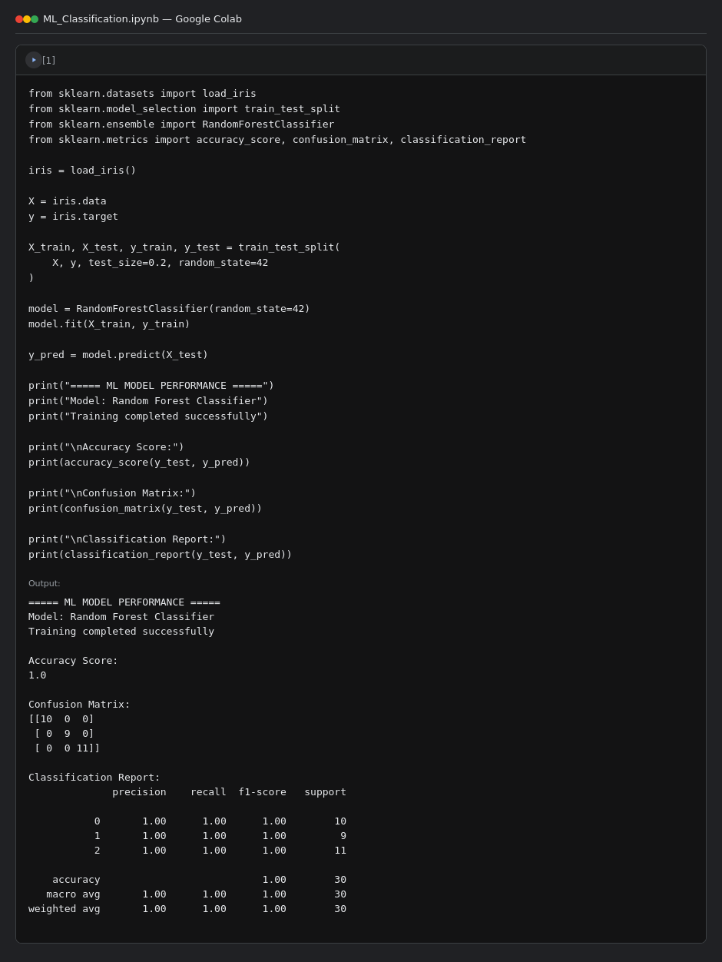  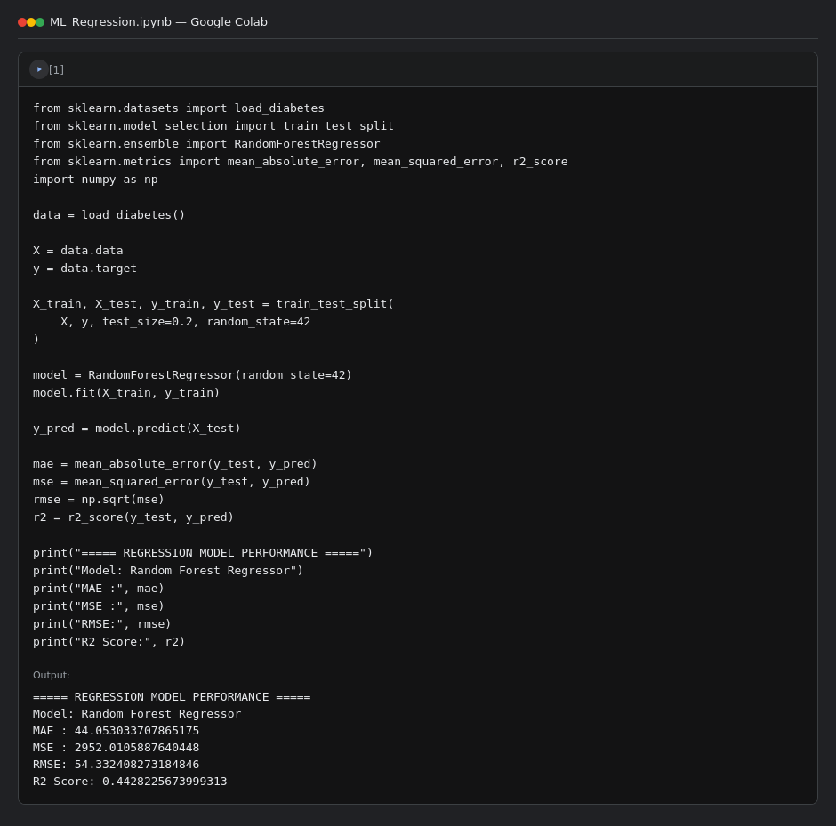
 | Tune the Model | Hyperparameter Tuning - GridSearchCV over n_estimators: [50, 100], max_depth: [None, 5, 10]  Best Parameters - max_depth: None, n_estimators: 50  Best Validation Score - 0.9417  Validation Method - 5-fold Cross-Validation (cv=5) | 